Activity: • Build a delivery pipeline using Jenkins. The source code is kept in https://github.com/AnjuMeleth/hello-world-java.git • Steps: • Create a Freestyle project and name it as HelloWorldJava • Select “Execute shell” under “Build” section. • Enter the commands git clone https://github.com/AnjuMeleth/hello-world-java.git cd hello-world-java javac HelloWorld.java java HelloWorld • Save and Build Now

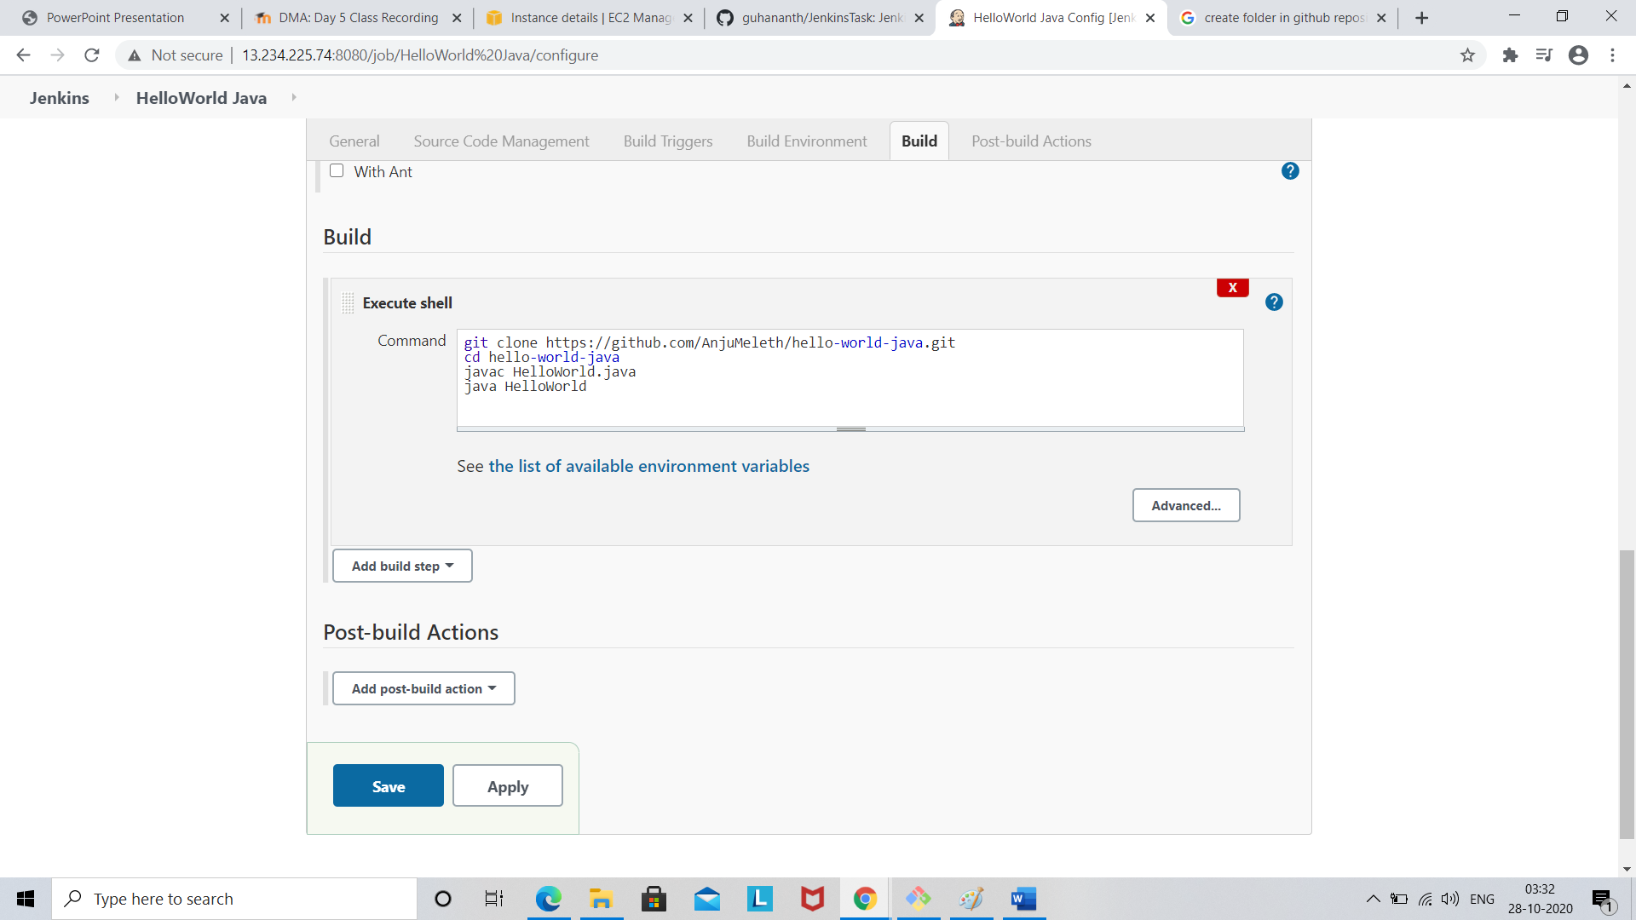

Click Save

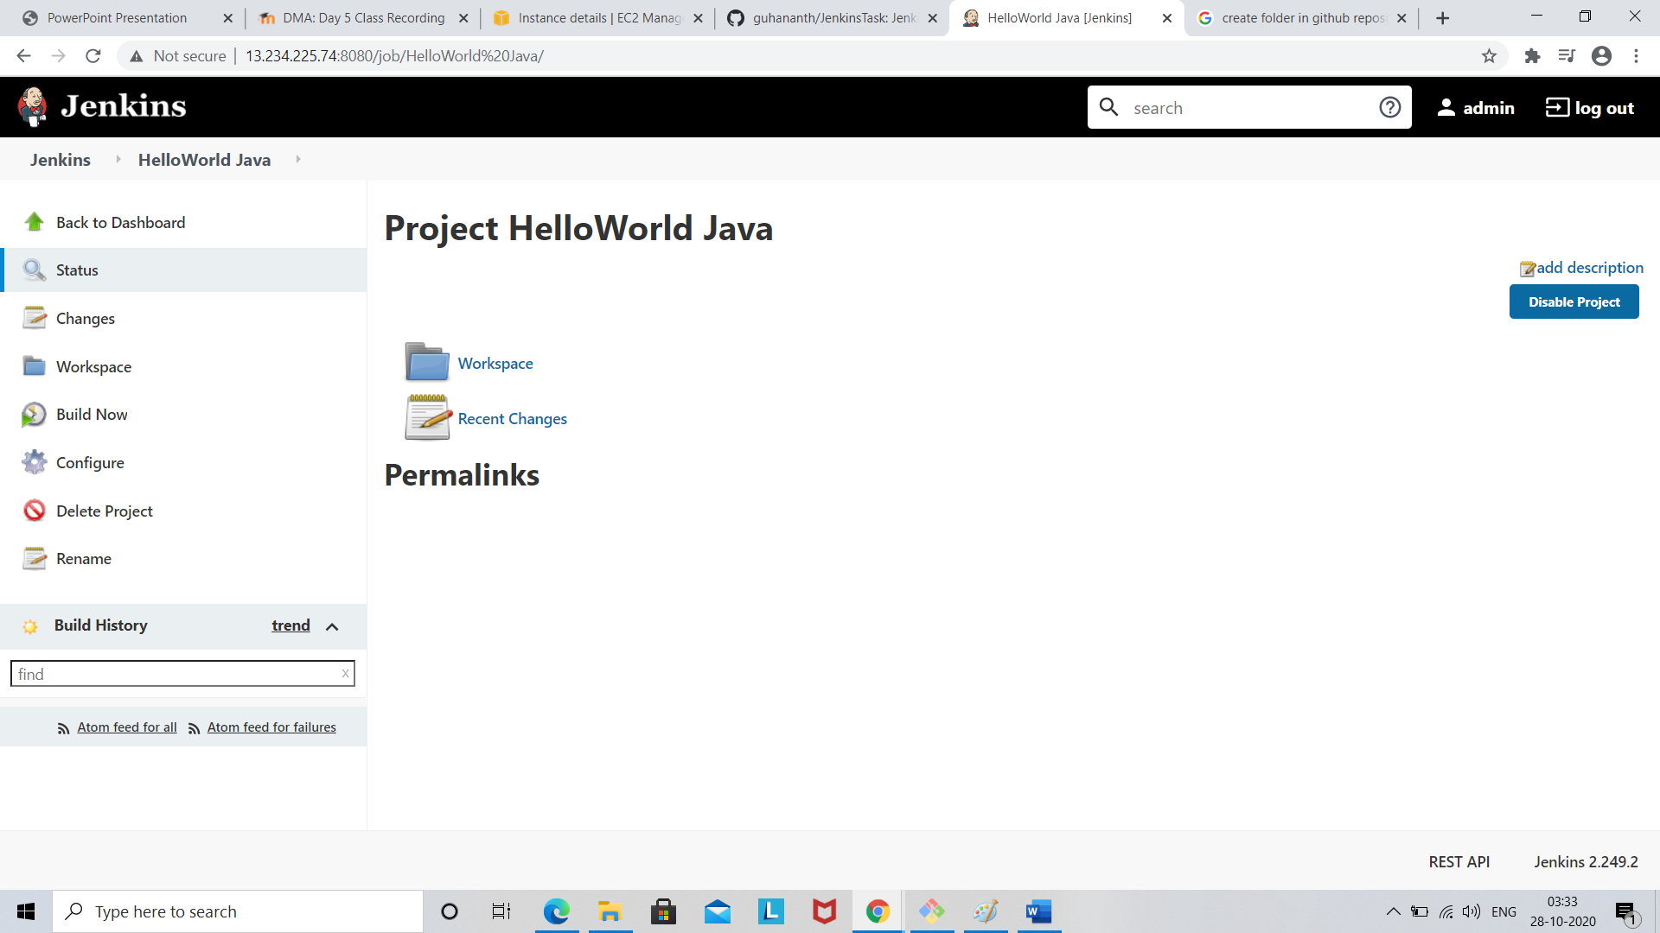

Click build now

